Project Design Phase-I Solution Architecture

|  |  |
| --- | --- |
| Date | 22 November 2023 |
| Team ID | Team-593176 |
| Project Name | Market Segmentation Analysis |
| Maximum Marks | 4 Marks |

Solution Architecture:

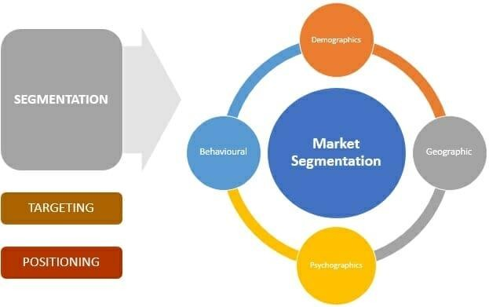

Market Segmentation Analysis

Algorithms for market segmentation.

The objective is to understand the marketing needs and desires of consumers to effectively match them with suitable supplier offers.

This is done by the different steps of implementation such as:

1. Data Collection and Preprocessing

2. Feature Selection

3. Model Selection and Training : The algorithms used are :

KNN , XGBoost , Random Forest classifier , Decision tree and Extratre classifier

4. Model Evaluation and Validation

5. Flask deployment

This model would predict the frequency of visits by the customers and shows relations on what factors the outcome is dependent and can be improved for better developement and increase in sales of the company